**Tymon BielskiIndex: 193729Group: 3/1Term Code: czwartek_15**

**Project Subject**

**Project Description**

**Project Details**

**ERD Diagram**

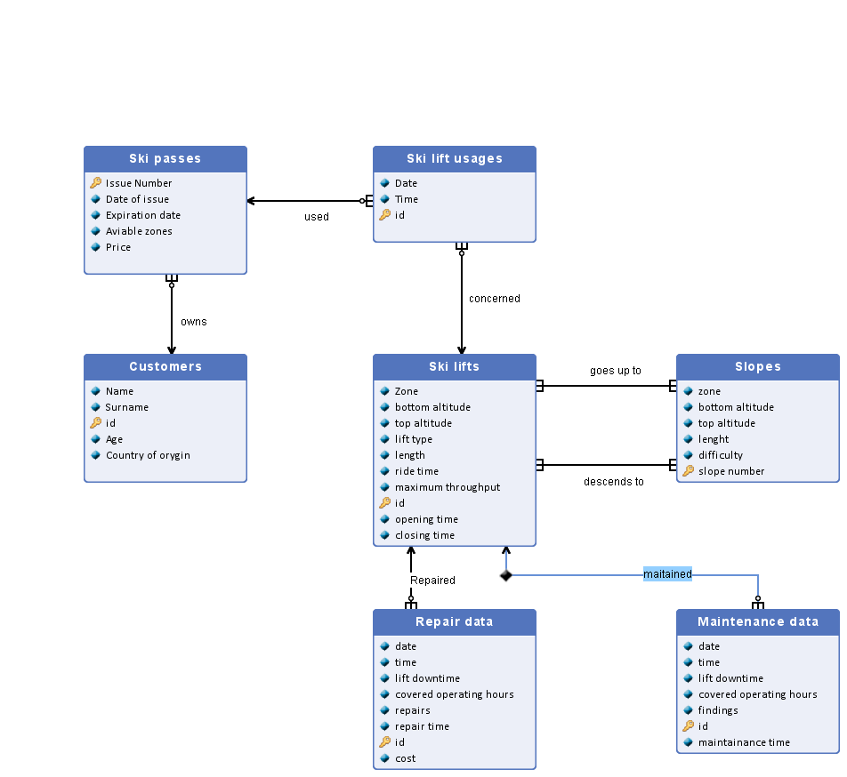

**Entity set description**

|  |  |  |  |  |  |
| --- | --- | --- | --- | --- | --- |
| **Customers** | | | | | |
| The table containing data on all current and past owners of ski passes. New enteries added whenever a new customer buys a ski pass and are never removed. Cardinality: ~100 000 | | | | | |
| **Name** | **Primary key** | **Type/Domain** | **Description** | | |
| Name | No | String | Name of the customer | | |
| Surname | No | String | Surname of the customer | | |
| id | **Yes** | int | Main differentiation method for customers | | |
| Age | No | int | Age of the customer in years | | |
| Country of orygin | No | String | The country where the customer currently presides in | | |

|  |  |  |  |  |  |
| --- | --- | --- | --- | --- | --- |
| **Ski passes** | | | | | |
| The table containing information on all ski passes issued during a given ski season. New enteries are added whenever a ski pass is issued and all ski passes not valid for the next season are removed at the end of one. Cardinality: ~10 000 | | | | | |
| **Name** | **Primary key** | **Type/Domain** | **Description** | | |
| Issue Number | **Yes** | int | Number given to each ski pass upon issuing | | |
| Date of issue | No | Date | The date on which the ski pass was oryginally issued | | |
| Expiration date | No | Date | The last day on which the ski pass grants entry on the ski lifts | | |
| Aviable zones | No | byte | List of zones saved in a binary format, in which the ski pass is valid | | |
| Price | No | Double | Price of the ski pass in euros | | |

|  |  |  |  |  |  |
| --- | --- | --- | --- | --- | --- |
| **Ski lift usages** | | | | | |
| Table containing data on singular instances of ski lift access. New enteries are added whenever a ski pass owner uses a ski lift and all enteries are removed at the end of a ski season. Cardinality: ~1 000 000 | | | | | |
| **Name** | **Primary key** | **Type/Domain** | **Description** | | |
| Date | No | Date | Date of usage | | |
| Time | No | Time | Time of usage | | |
| id | **Yes** | int | id of usage | | |

|  |  |  |  |  |  |
| --- | --- | --- | --- | --- | --- |
| **Ski lifts** | | | | | |
| Table containing data on ski lifts in the resort. New enteries are added whenever a new ski lift is built and deleted whenever one is removed. Cardinality: ~30 | | | | | |
| **Name** | **Primary key** | **Type/Domain** | **Description** | | |
| Zone | No | char | the resort zone in which the lift is located | | |
| bottom altitude | No | double | the altitude in meters above the sea level at which the boarding station is locateda | | |
| top altitude | No | double | the altitude in meters above the sea level at which the offboarding station is locateda | | |
| lift type | No | enum | One of 4 types of ski lifts (magic carpet, rope tow, chairlift, gondola) | | |
| length | No | double | length of the ski lift in meters | | |
| ride time | No | double | the time taken by the lift to traverse from the bottom station to the top station in seconds | | |
| maximum throughput | No | int | theoretical maxim amount of customers that can use the lift in 1 hour | | |
| id | **Yes** | int | identification number of the ski lift | | |
| opening time | No | time | the time on which the lift opens to skiers | | |
| closing time | No | time | the time of the last call for the lift | | |

|  |  |  |  |  |  |
| --- | --- | --- | --- | --- | --- |
| **Slopes** | | | | | |
| Table containing data on ski slopes in the resort. New enteries are added whenever a new ski slope is built and deleted whenever one is removed. Cardinality: ~50 | | | | | |
| **Name** | **Primary key** | **Type/Domain** | **Description** | | |
| zone | No | char | the resort zone in which the slope is located | | |
| bottom altitude | No | double | the altitude in meters above the sea level at which the slope ends | | |
| top altitude | No | double | the altitude in meters above the sea level at which the slope starts | | |
| lenght | No | double | length of the ski slope in meters | | |
| difficulty | No | enum | one of the 5 difficulties of slopes (green, blue, red, black, double black) | | |
| slope number | **Yes** | int | the number given to the slope for navigation purposes | | |

|  |  |  |  |  |  |
| --- | --- | --- | --- | --- | --- |
| **Maintenance data** | | | | | |
| Table containing data onall maintainance done on lifts in the resort. New enteries are added whenever a new maintainance is performed and deleted whenever its corresponding lift is removed is removed. Cardinality: ~100 000 | | | | | |
| **Name** | **Primary key** | **Type/Domain** | **Description** | | |
| date | No | date | the date on which the maintainance started | | |
| time | No | time | the time on which the maintainance started | | |
| lift downtime | No | int | how long was the lift unable to be operated because of the maintainance in minutes | | |
| covered operating hours | No | boolean | wether the maintainance happened to encroach on the lift's operating time | | |
| findings | No | string | a short summary on what the maintainance uncovered | | |
| id | **Yes** | int | identification number of the maintainance session | | |
| maintainance time | No | int | how long did the maintainance take in minutes | | |

|  |  |  |  |  |  |
| --- | --- | --- | --- | --- | --- |
| **Repair data** | | | | | |
| Table containing data onall repairs done on lifts in the resort. New enteries are added whenever a new repair is performed and deleted whenever its corresponding lift is removed is removed. Cardinality: ~1 000 | | | | | |
| **Name** | **Primary key** | **Type/Domain** | **Description** | | |
| date | No | date | the date on which the repair started | | |
| time | No | time | the time on which the repair started | | |
| lift downtime | No | int | how long was the lift unable to be operated because of the maintainance in minutes | | |
| covered operating hours | No | boolean | wether the maintainance happened to encroach on the lift's operating time | | |
| repairs | No | string | a short summary on what the repairs were and how they were conducted | | |
| repair time | No | int | how long did the maintainance take in minutes | | |
| id | **Yes** | int | identification number of the maintainance session | | |
| cost | No | double | the cost of parts and equipement required to fully repair the ski lift | | |

**Relationships description**

|  |
| --- |
|  |
| **Name** | **Entity set 1** | **Entity set 2** | **Cardinality** | **Description** | |
| goes up to | Ski lifts | Slopes | 1..n : 1..n | What ski lift leads to what slope. | |
| concerned | Ski lift usages | Ski lifts | 0..n : 1 | Ski lifts concerned for a given ski lift usage. | |
| maitained | Ski lifts | Maintenance data | 1 : 0..n | maintainance pretaining to a given ski lift. | |
| used | Ski passes | Ski lift usages | 1 : 0..n | Ski passes used for a given ski lift use. | |
| owns | Ski passes | Customers | 0..n : 1 | Ski passes currently owned by given customers. | |
| descends to | Ski lifts | Slopes | 1..n : 1..n | what ski slope leads to what ski lift. | |
| Repaired | Ski lifts | Repair data | 1 : 0..n | repairs pretaining to a given ski lift. | |

**Relational Database Schema**